Decision Making Statement
______________________________________________________________________________
Decision making statement is used for to work with conditional programming means if we have some condition and if we want to execute the logic after the condition then we can use decision making statement.

Types of decision making statement
______________________________________________________________________________
1. Simple if statement
2. If else statement
3. Else if ladder statement
4. Nested if statement
5. Switch statement

Simple if statement: if we think about simple if statement then we have single if with condition there is no else or else if
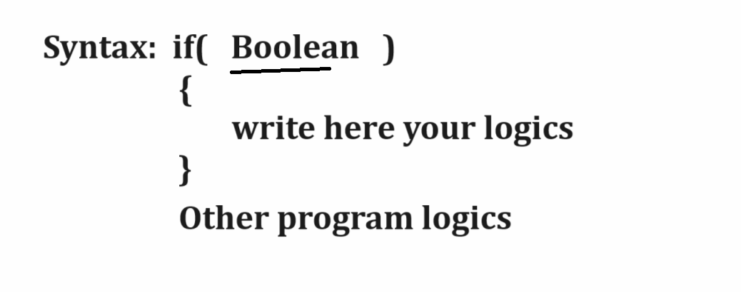

Example: WAP to input number from keyboard and check number is even or odd.
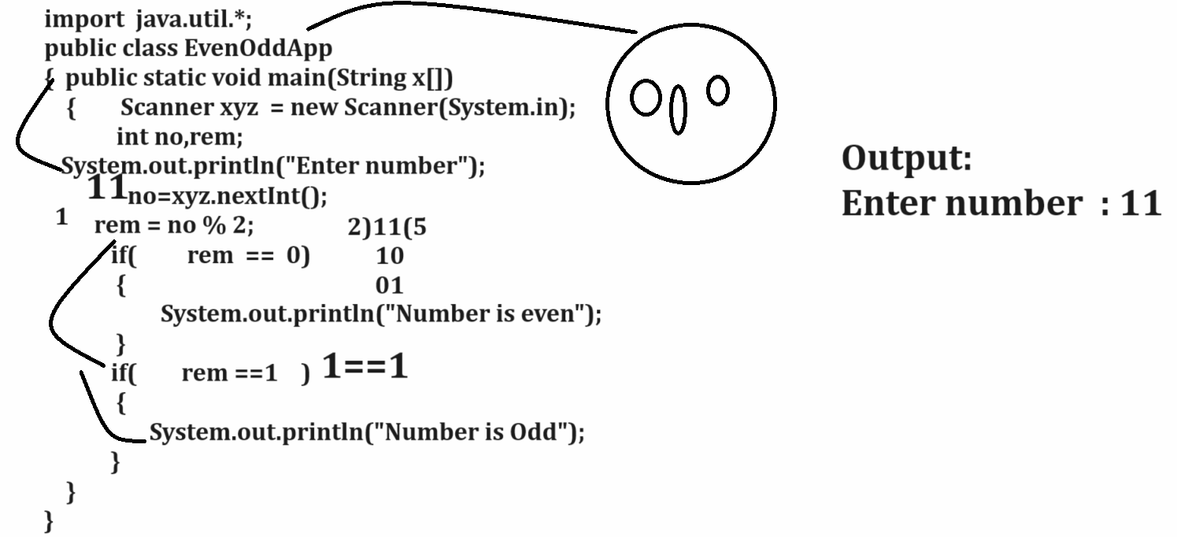

Example: WAP to input the quantity and rate of product from keyboard and calculate its total and if total is greater than 2000 then give discount 10% otherwise there is no discount.
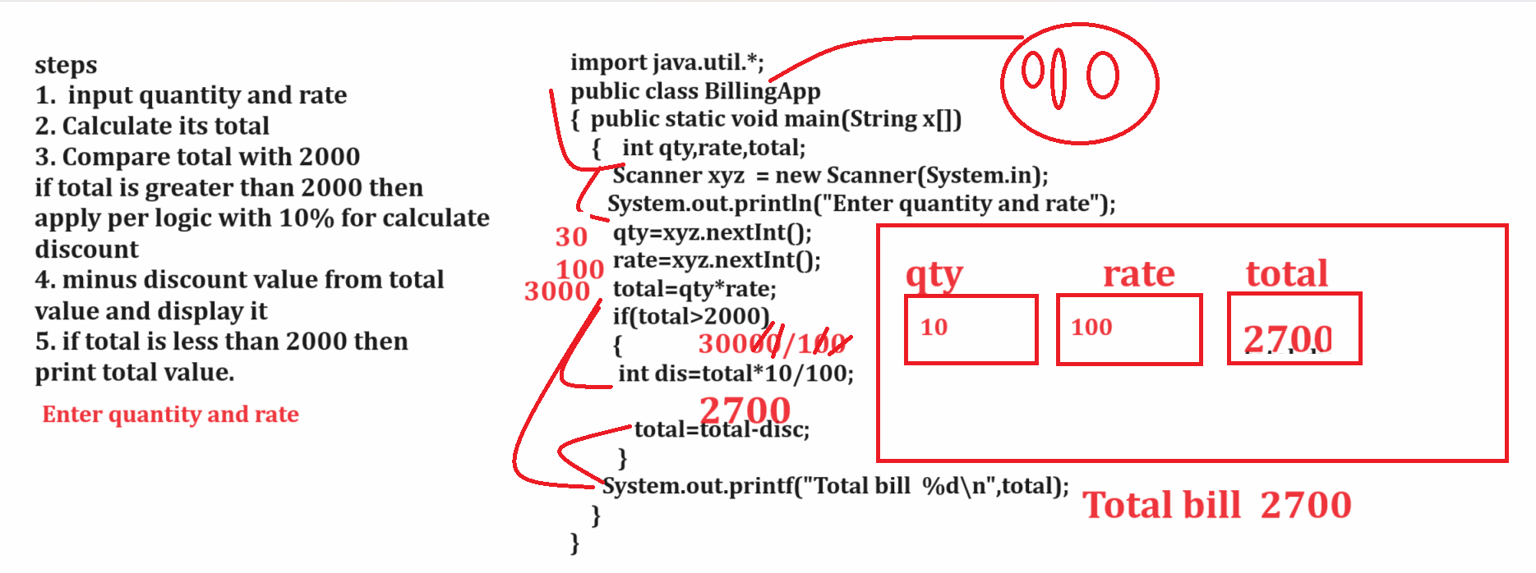

Example: WAP to input number and check number is palindrome or not
Palindrome means original number and reverse number should be same
Input: 121
Output: 121 - palindrome
Input: 124
Output: 421 – not palindrome
import java.util.*;
public class Palindrome
{
public static void main(String x[])
{
Scanner xyz = new Scanner(System.in);
int no,temp;
System.out.println("Enter three digit number");
no=xyz.nextInt();
temp=no;
no = (no%10)*100 +((no/10)%10)*10 +no/100;
if(no==temp)
{ System.out.println("Number is palindrome");
}
else{
System.out.println ("Number is not palindrome");
}
}
}
If else statement
______________________________________________________________________________
If else statement is used for when we have two conditions exact opposite of each other then we can use if else statement.
Syntax:
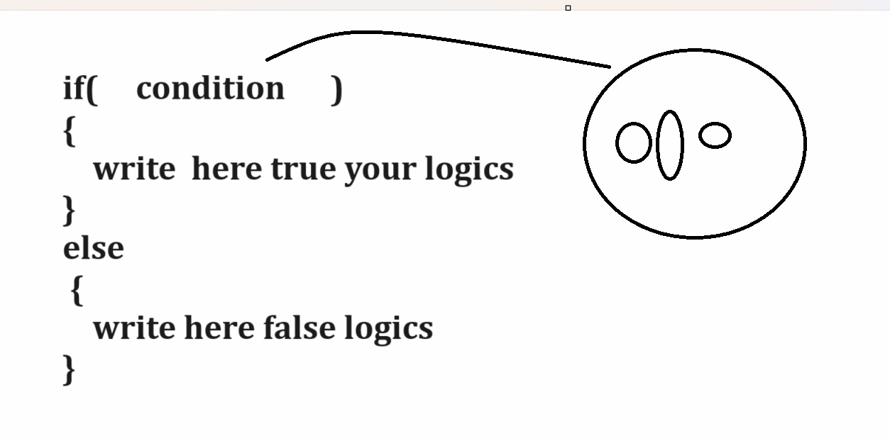
Example with source code
import java.util.*;
public class CheckGreaterApp
{
public static void main(String x[])
{
int a,b;
Scanner xyz = new Scanner(System.in);
System.out.println("Enter two values");
a=xyz.nextInt();
b=xyz.nextInt();
if(a>b)
{ System.out.println("A is Greater");
}
else{
System.out.println("B is Greater");
}
}
}

Example: WAP to input character from keyboard and convert lower case character to upper case and upper-case character to lower case.
Note: if we want to solve this problem we should have to know ASCII code.
Q. What is ASCII?
______________________________________________________________________________
ASCII stands for American standard code for information and interchange called as ASCII.
Def: ASCII is intermediate language which is used for converting your any character from keyboard into digit format and store in computer system.
There is total 256 ASCII code
A= 65 to Z = 90
a= 97 to z= 122
0= 48 to 9= 57

Q. Can we see the ASCII code of character?
Yes, we can see the ASCII code of character.

Example with source code
public class CheckAsciiApp
{ public static void main(String x[])
{ char ch='a';
System.out.printf("%d",(int)ch);
}
}
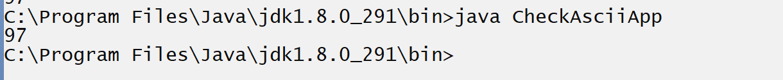

import java.util.*;
public class CheckConvertApp
{
public static void main(String x[])
{
Scanner xyz = new Scanner(System.in);
char ch;
System.out.println("Enter character from keyboard");
ch=xyz.nextLine().charAt(0);
System.out.printf("Before conversion %c\n",ch);
if(ch>=65 && ch<=90)
{
ch=(char)((int)ch+32);
}
else
{ ch=(char)((int)ch-32);
}
System.out.printf("After conversion %c\n",ch);
}
}

else if ladder
______________________________________________________________________________
Else if ladder means we have multiple if with else keyword as well as with single else
When we have multiple conditions, and every condition want to work independent condition then we can use else if ladder
Syntax
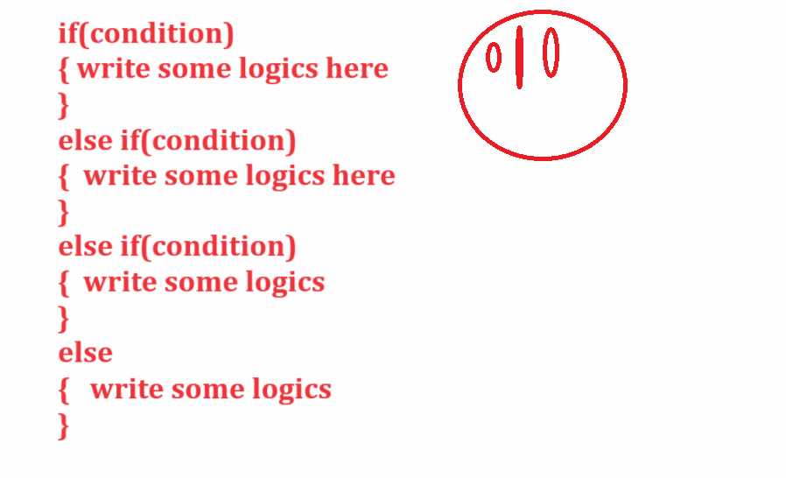
Example: WAP to input three values and check which is greater
import java.util.*;
public class CheckGreaterThreeApp
{
public static void main(String x[])
{
Scanner xyz = new Scanner(System.in);
int a,b,c;
System.out.println("Enter three values");
a=xyz.nextInt();
b=xyz.nextInt();
c=xyz.nextInt();
if(a>b && a>c)
{ System.out.println("A is Greater");
}
else if(b>a && b>c)
{ System.out.println("B is Greater");
}
else
{
System.out.println("C is Greater");
}
}
}

Example: WAP to input character from keyboard and check character is alphabet or digit or special symbol.
Output:
Input Character: A
Output: alphabet
Input Character: 9
Output: digit

Example with source code
import java.util.*;
public class CheckAsciiApp
{
public static void main(String x[])
{ Scanner xyz = new Scanner(System.in);
char ch;
System.out.println("Enter character from keyboard");
ch=xyz.nextLine().charAt(0);
if(ch>=48 && ch<=57)
{ System.out.println("Digit");
}
else if(ch>=97&& ch<=122)
{ System.out.println("Small alphabet");
}
else if(ch>=65 && ch<=90)
{ System.out.println("Capital alphabet");
}
else
{ System.out.println("Special symbol");
}
}
}
Nested if statement
______________________________________________________________________________
Nested if statement means if we have some conditions and dependent on some another condition then we can use nested if statement.
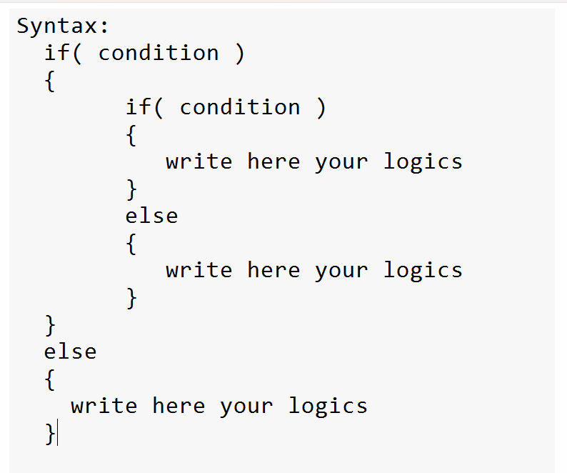

Example: WAP to input the id and salary of employee and if id between 1 to 100 and salary is greater than 10000 then we can announce employee is permanent and if id between 1 to 100 and salary is less than 10000 then employee is temporary and if id less not between 1 to 100 then candidate is not employee.

Example with source code
import java.util.*;
public class NestedApp
{ public static void main(String x[])
{ Scanner xyz = new Scanner(System.in);
System.out.println("Enter id of employee");
int id=xyz.nextInt();
if( id>=1 && id<=100 )
{ System.out.println("Enter salary of employee");
int salary=xyz.nextInt();
if( salary>=10000 )
{ System.out.println("Employee is permanent");
}
else{
System.out.println("Employee is temporary");
}
}
else
{
System.out.println("Candidate is not employee");
}
}
}

Example: WAP to input the quantity and rate of product and if quantity is greater than 10 then calculate the total of product and if
Total bill of product is greater than 10000 then give discount of 20%
Otherwise give discount of 10% and if quantity is less than 10 then don’t take order.

Example with source code
import java.util.*;
public class TotalBillApp
{ public static void main(String x[])
{ Scanner xyz = new Scanner(System.in);
int qty,rate,total;
System.out.println("Enter quantity ");
qty=xyz.nextInt();
if(qty>10)
{
System.out.println("Enter rate of product");
rate=xyz.nextInt();
total=qty*rate;
if(total>10000)
{ int dis=total*20/100;
total =total-dis;
System.out.printf("Total bill is %d\n",total);
}
else{
int dis=total*10/100;
total =total-dis;
System.out.printf("Total bill is %d\n",total);
}
}
else
{ System.out.println("Order not proceed");
}
}
}

Switch statement
______________________________________________________________________________
Switch statement is used for work with menu driven or choice base application.
Syntax:
switch(choice)
{ case 1:
write here your logics
break;
case 2:
write here your logics
break;
case n:
write here your logics
break;
default:
write here your logics
}
Example: WAP to input two values and perform operation on it using following conditions.
case 1: Addition
case 2: Multiplication
case 3: Division
Example with source code
import java.util.*;
public class SwitchApp
{
public static void main(String x[])
{
Scanner xyz = new Scanner(System.in);
int a,b,choice;
System.out.println("Enter two values");
a=xyz.nextInt();
b=xyz.nextInt();
System.out.println("1:Addition");
System.out.println("2:Multiplication");
System.out.println("3:Division");
System.out.println("Enter your choice");
choice=xyz.nextInt();
switch(choice)
{
case 1:
System.out.printf("Addition is %d\n",a+b);
break;
case 2:
System.out.printf("Multiplication is %d\n",a*b);
break;
case 3:
System.out.printf("division is %d\n",a/b);
break;
default:
System.out.println("Wrong choice");
}
}
}

Example: WAP to input character from keyboard and check character is vowel or consonant using switch statement.

